Tanmay Fadnavis

SUID: 971141760

Computer Security

Lab - 1

# TASK 1: MANIPULATING ENVIRONMENT VARIABLES

1. We run the printenv command to print the environment variables. Below is the screen shot for the same.

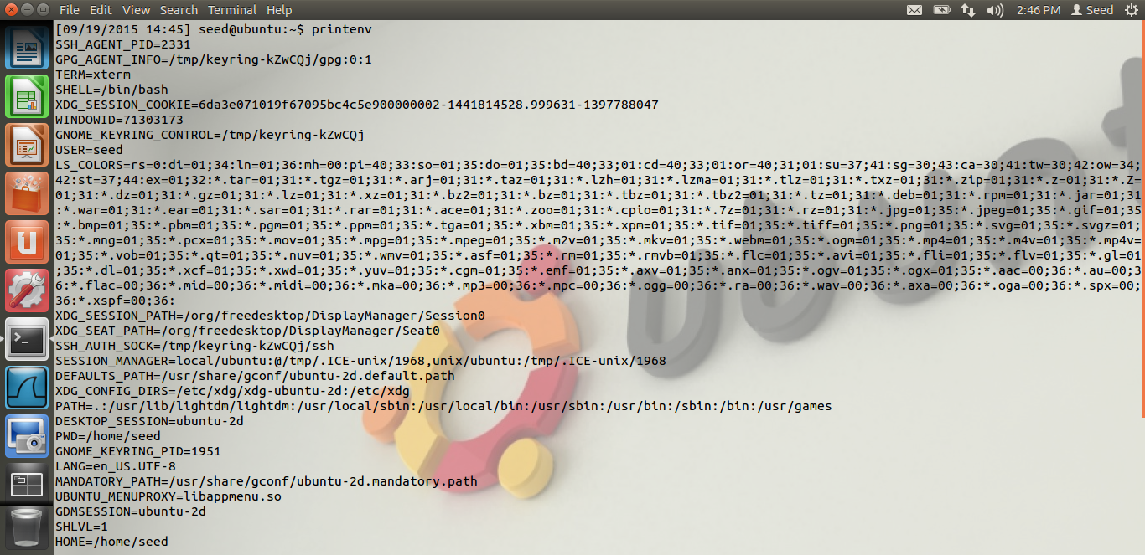

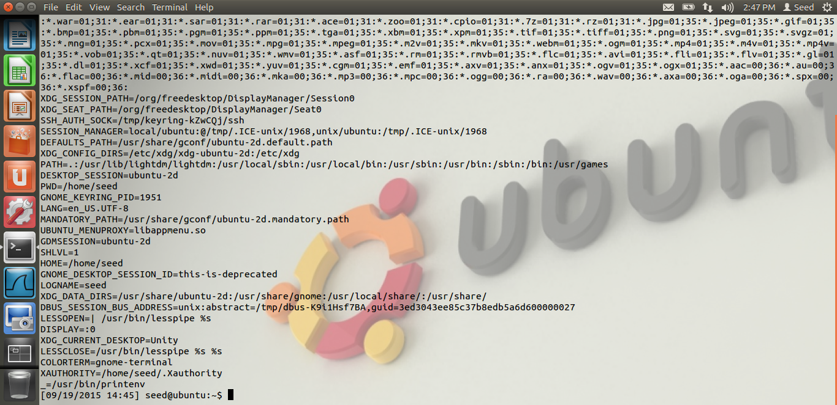

**Observation**: Above we see all the environment variables using the printenv command.

1. Below is the screen shot for the environment variables using the env command.

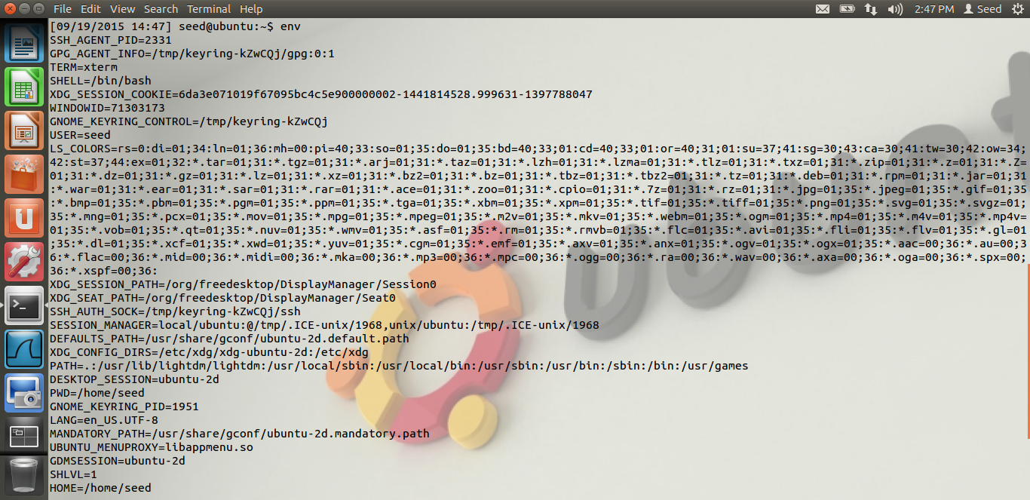

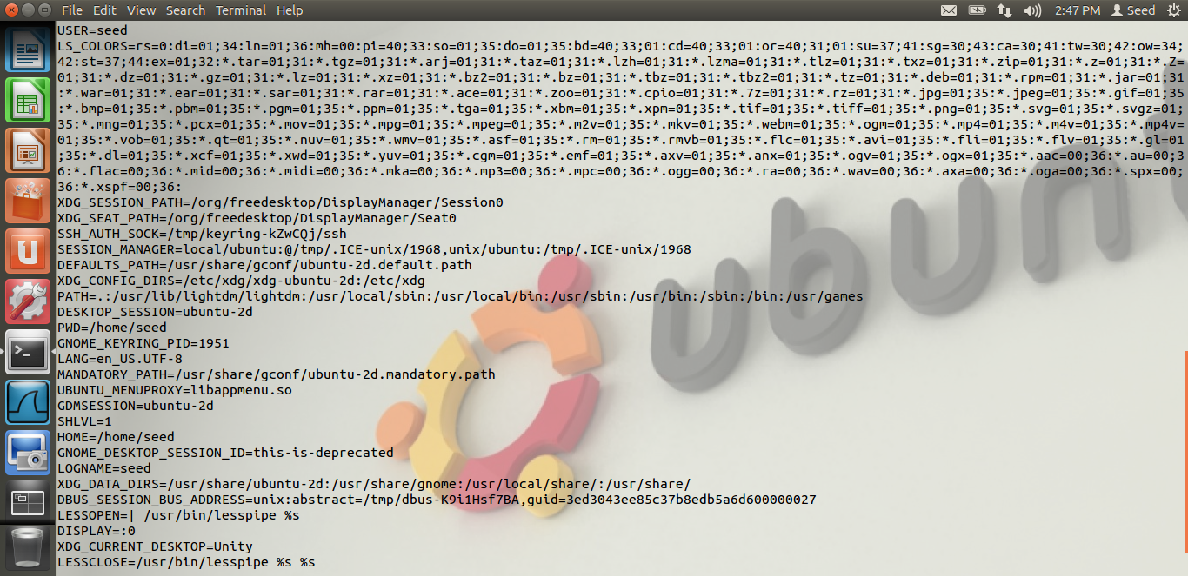

1. Below is the screen shot which shows a particular environment variable using the printenv and the env command.

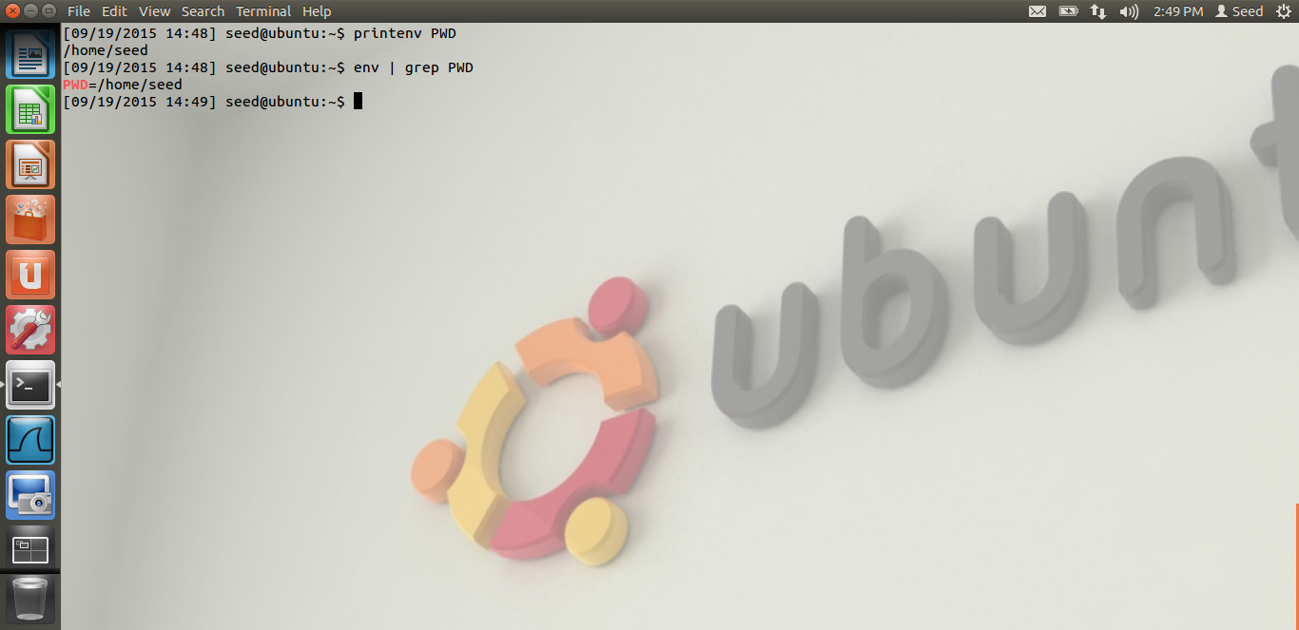

**Observation:** As we can see, we are displaying just the PWD environment variable.

1. Below is the screen shot for the export and unset command.

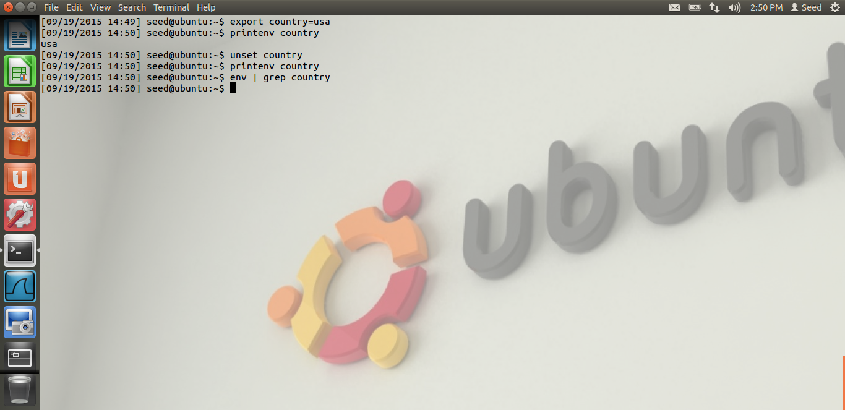

**Observation:** We are exporting an environment variable called country and setting its value to “usa”. We can see the environment variable using the printenv command. Then, we are unsetting the “country” variable using the unset command. After the variable is unset, when we try to display it using either the printenv or the env command, its not getting displayed as the variable has been unset.

# TASK 2: INHERITING ENVIRONMENT VARIABLES FROM PARENT

Below is the screen shot for Task2.

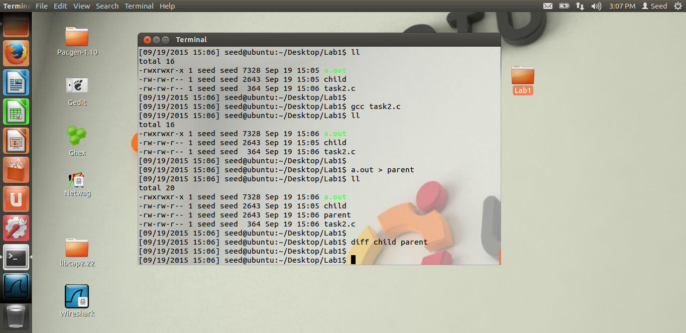

**Observation:** We can see in the screen shot that the program given by Dr. Du, is the task2.c program. A.out is the executable file. And the output of a.out is put in “child” file. Then the program is run again by running the parent process printenv() statement as mentioned in the Lab. The output is directed to the “parent” file. In the screen shot we can see that when we run the diff command “diff child parent”, we don’t get any output. This means that both the “child” and the “parent” files are the same. Thus, we conclude that the child process inherits all the environment variables from its parent process by performing the above task.

# TASK 3: ENVIRONMENT VARIABLES AND execve()

Below are the screen shots for task3.

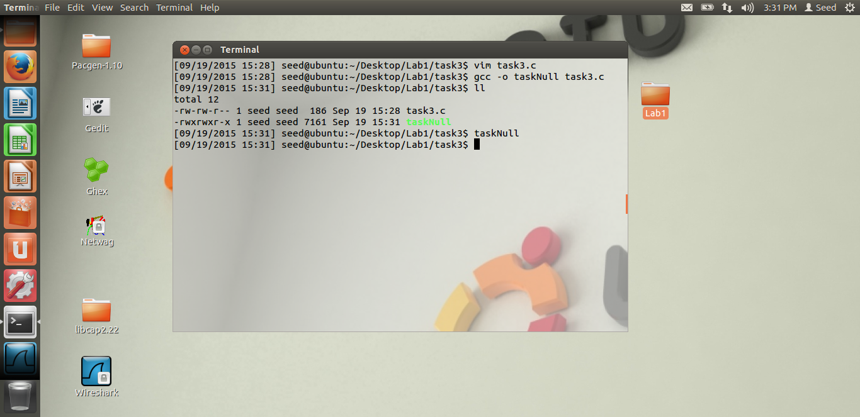

**Observation:** When we first execute the execve() with NULL, as we can see from the screen shot, we cannot see any environment variables being displayed. When we execute the executable file “taskNull”, even though we are calling the /usr/bin/env in the execve(), we are not able to see the environment variables. Thus, they are not automatically inherited by the new program.

Below is the screen shot when we execute the program with environ variable being passed.

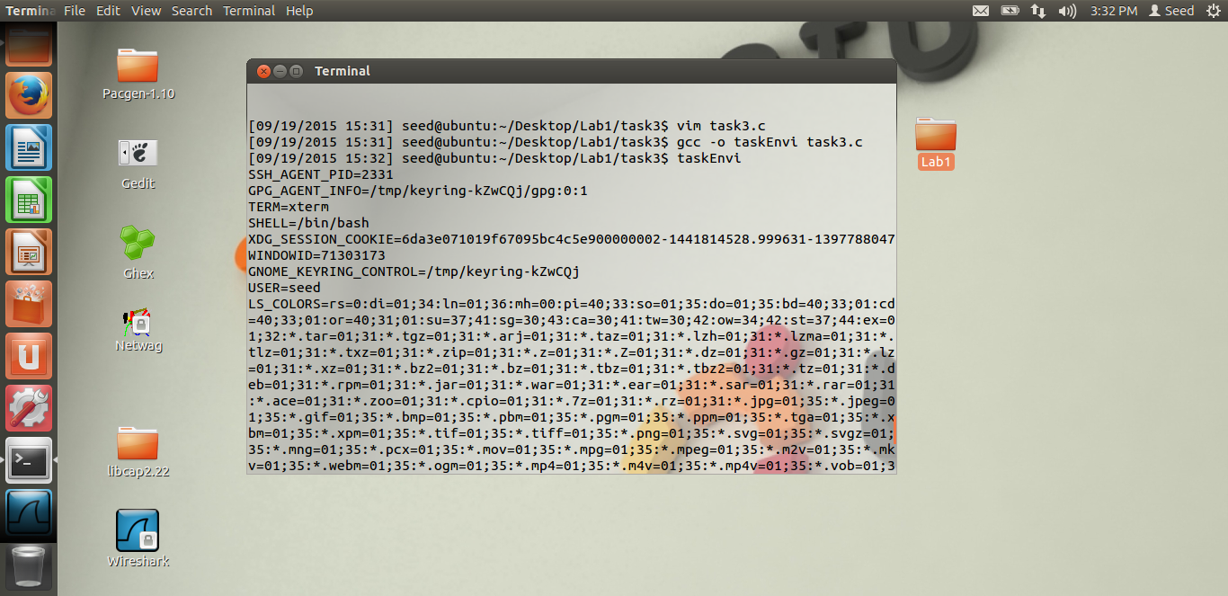

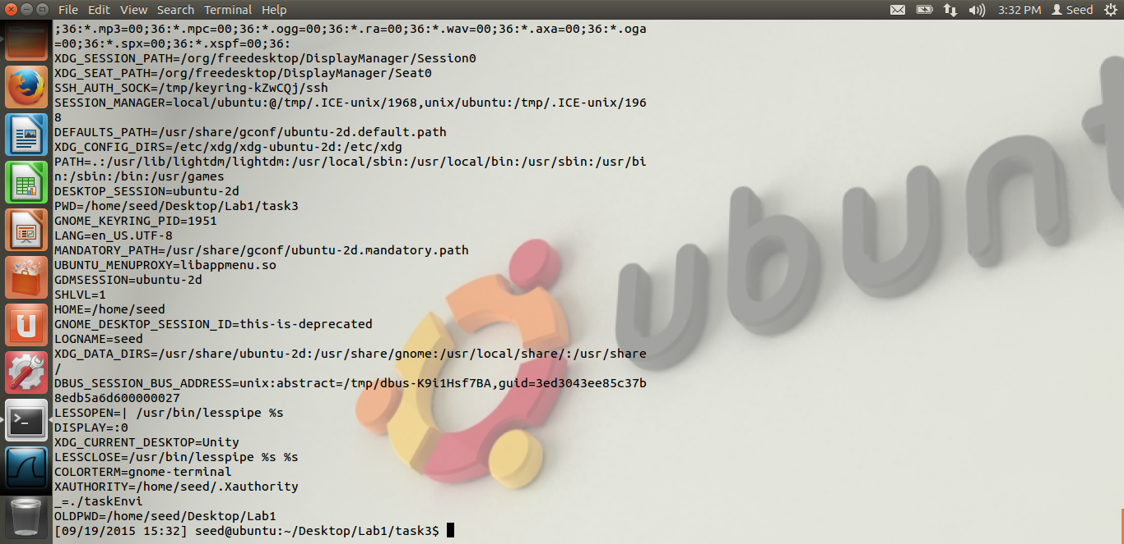

**Observation:** Thus, from the above screen shot, when we pass the environ variable to the execve() function as a parameter, we are able to see all the environment variables when we execute the code. We conclude that, as we are passing the environment variable explicitly, we are able to see the environment variables. Again, we conclude that the new program gets its environment variables, only when we pass them to the execve() function.

# TASK 4: ENVIRONMENT VARIABLES AND system()

Below is the screen shot for Task 4.

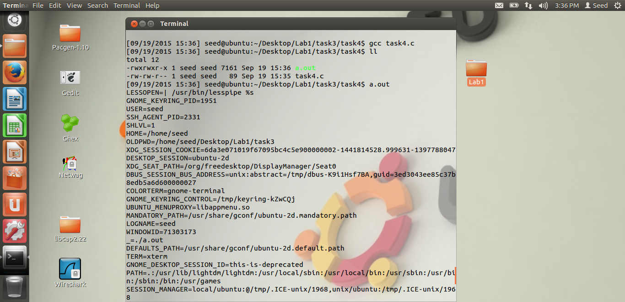

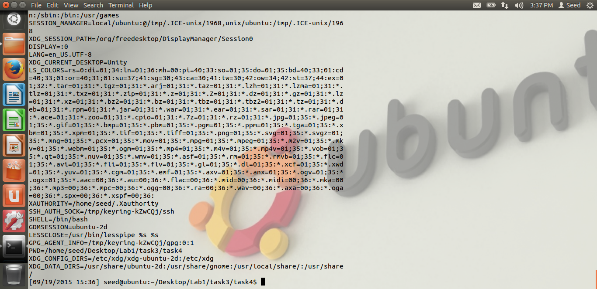

**Observation:** As we can see from the screen shot, we have compiled Dr Du’s code in task4.c After we run the a.out, i.e. the executable file, we are able to see all the environment variables. Even though we are not explicitly passing the environment variables, unlike execve(), the system is getting all the environment variables. The reason is, execve() calls a system call to load a new command. They are not automatically inherited in the new program. But when we run the system(), the system() executes /bin/sh, it executes the shell, it uses execl(), which in turn calls the execve() passing it the environment variables array. Thus, as the shell passes the array to execve(), we are able to see the environment variables. Hence, we should not use system() in the privileged programs.

# TASK 5: ENVIRONMENT VARIABLE AND Set – UID PROGRAMS

Below are the screen shots for task5.

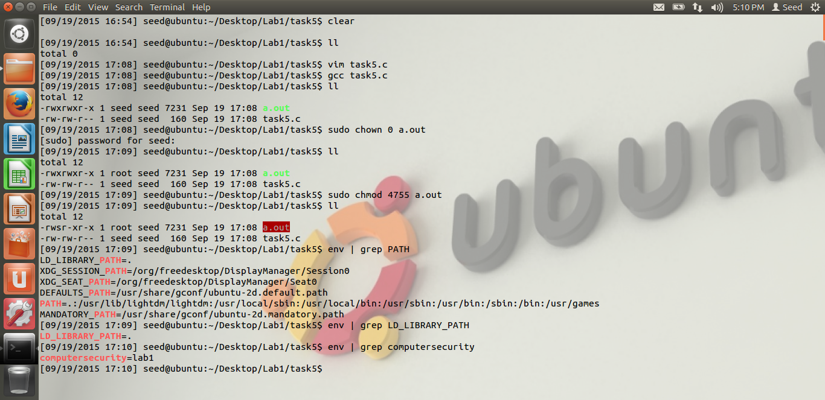

**Observation:** In the above screen shot, we see that, we have compiled Dr. Du’s program in task5.c The executable file is a.out. We have changed its ownership to root using chown 0 a.out. Also we have made it a set-UID program, using chmod 4755 a.out. We can see this from the screen shot, as the color is red, and we can see the owner is root. Also, we can see the environment variables PATH, LD_LIBRARY_PATH, by using the env | grep LD_LIBRARY_PATH and the “computersecurity” environment variable in the screen shot.

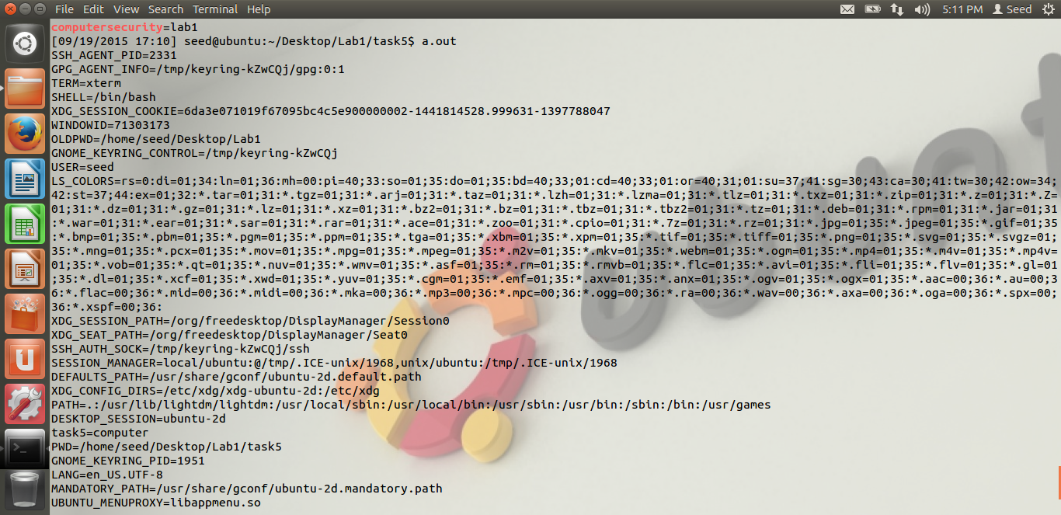

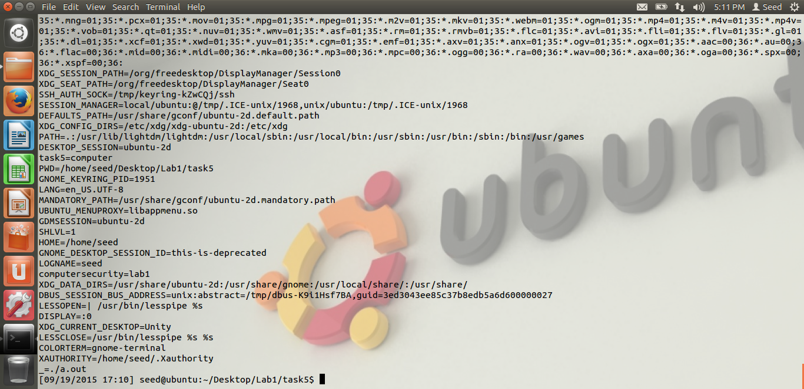

**Observation:** Now, when we run the set-UID program, we are able to see from the screen shots the environment variables. We can see the PATH variable, the “computersecurity” environment variable. But the difference is, as seen from the screen shot, we are not able to see the LD_LIBRARY_PATH environment variable, when we run the set-UID program. Thus, we conclude that LD_* environment variables are not inherited by the child process. Rest of the variables which we set in the parent process are inherited by the child process. The reason is, when we run the set-UID program, all the LD_* variables are cleaned before the program gets executed. Hence, we don’t see the LD_LIBRARY_PATH environment variable when we execute the set-UID program. Also, the “s” bit in the line stands for the set-UID bit.

# TASK 6: THE PATH ENVIRONMENT VARIABLE AND SET-UID PROGRAM

Screen shot for task6 are below.

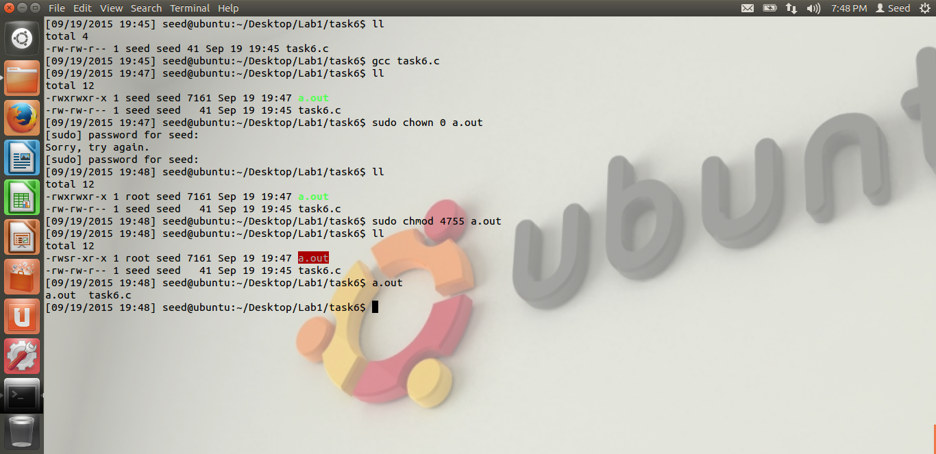

**Observation:** From the above screen shot, we just notice that we have compiled the code which calls the ls function using system, and we have made it a root owner and a set-UID program. In the screen, as the executable is in red, and we can see the owner is root. And it’s a set-UID program. Next step is to compile my own ls program instead of /bin/ls and try to call it.

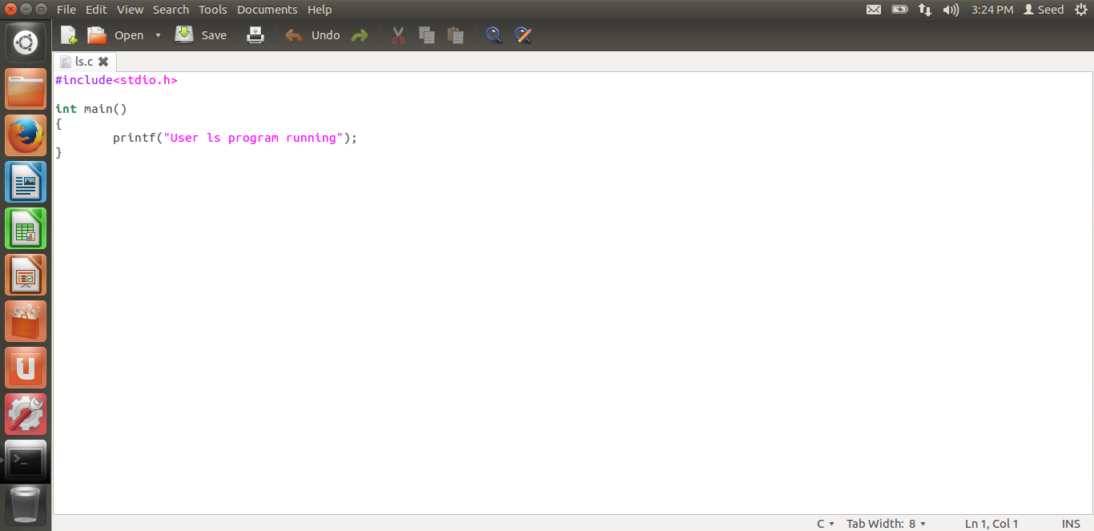

The above is the ls program written by me. It just contains a normal printf which states that this is a user ls program running.

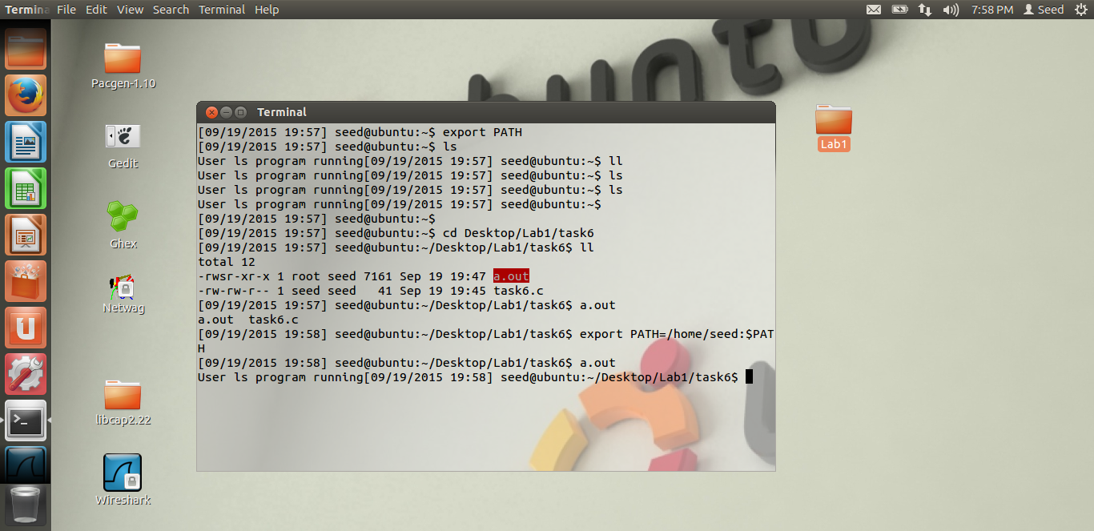

**Observation:** Now, we run the privileged a.out program. Before running the program, we change the PATH variable, as seen from the screen shot, by using the export statement, so that it uses our home directory PATH, on this path my ls program is compiled. Then, we run the a.out program. From the output, we see that it prints “User ls program running”, which is my program, instead of running the system “ls” programs which lists the file. Thus, we are successfully able to run our ls program from a root set-UID program.

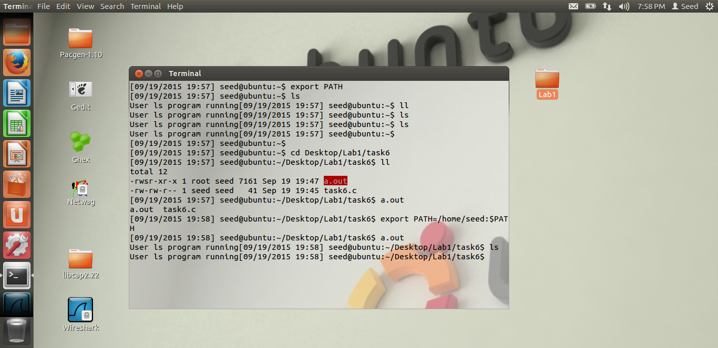

**Observation:** From the above screen shot, we can see that, even when we run the normal “ls” command, the printf statement in my user code is being executed. Thus, we are able to successfully attack the system.

# TASK 7: THE LD_PRELOAD ENVIRONMENT VARIABLE AND SET-UID PROGRAM

Below are the screen shots for Task-7

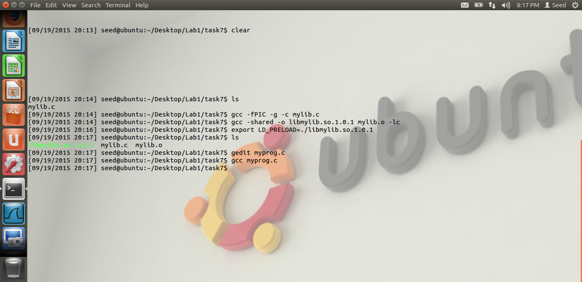

**Observation:** From the above screen shot, we just observer that, we have followed the first 4 steps mentioned in the lab. i.e. building DLL, compiling, setting the LD_PRELOAD using the export function and compiling the myprog.

Condition 1:

Myprog is regular and running as a normal user.

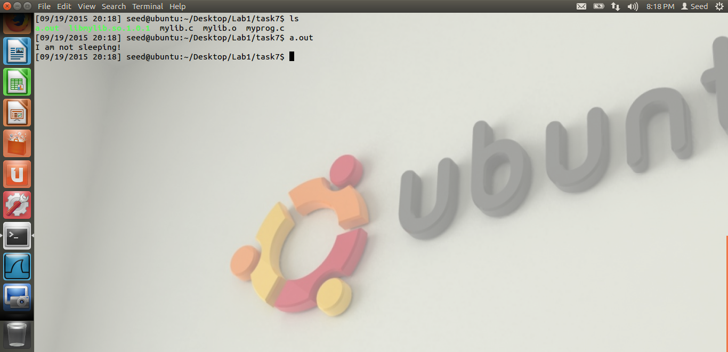

Observation: In the above screen shot, we can see that, when we run the a.out as a normal program, from the normal user i.e. seed, we get the output “I am not sleeping”. Thus, our own library has been inherited. As we have set it in the LD_PRELOAD, it uses our library.

Condition 2: make it a set-UID program and run it as a normal user.

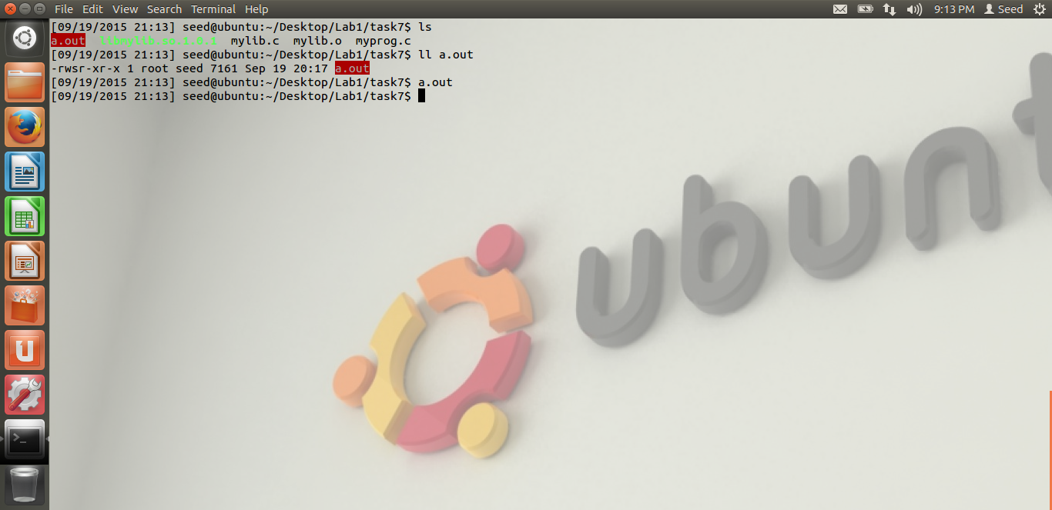

**Observation:** From the screen shot, we can observer that, we have made the program as s set-UID program from the “s” bit. Also the owner has been made as a root. But when we run this program as a normal user, it does not display “not sleeping” message as in the previous case. Instead, it calls the system sleep() function and sleeps for some time. The reason is, when a set-UID program is run, the child process does not inherit the LD_* variables. Thus, even though we export the LD_PRELOAD variable with out library, it cleans that before running the program. Hence, we don’t see any “not sleeping” display message and the program goes to sleep.

Condition 3: make it a set-UID program and run it from the root account.

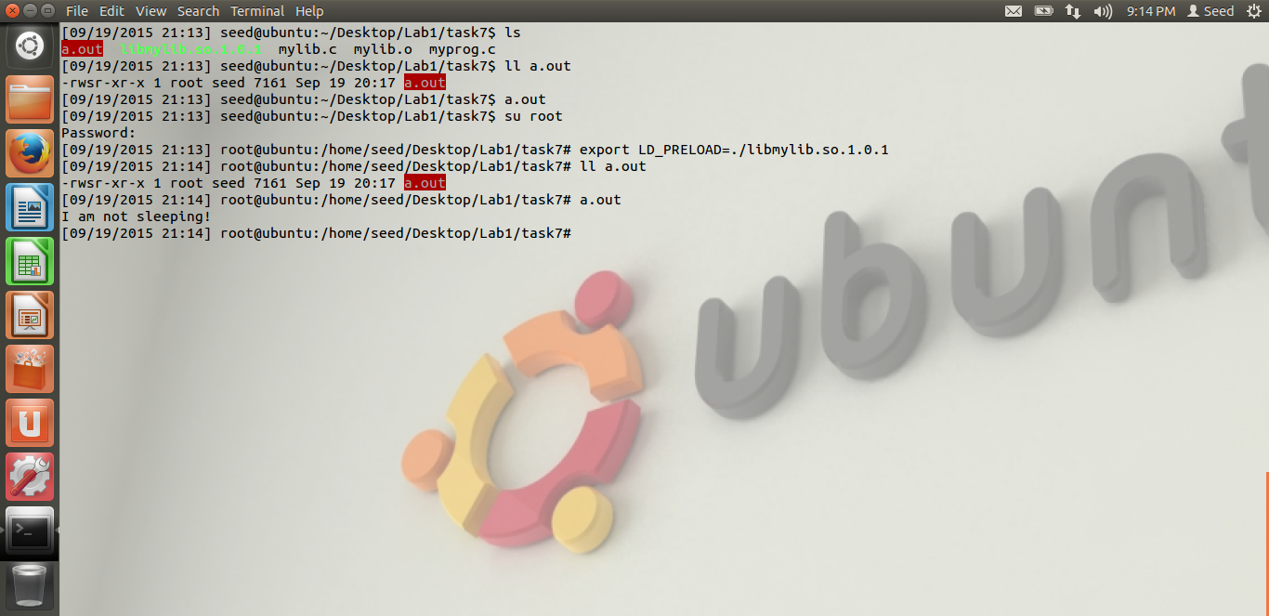

**Observation:** As we can see from the screen shot, we first login as root, using the su root. Then we export the library, as whenever we change the user, we have to export the library. Once that is done, the set-UID program, the owner is already root. So, when we run the program, our library is been loaded, i.e. we see the “I am not sleeping” display. The reason is, when we are logged in as a root and when we export the library, as the root user itself is exporting the library and we are in the root account, the library is loaded. Hence the library is called and we can see the output. The parent process itself is running, hence the library is being called.

Condition 4: Make it a set-UID of another user and run it from another user account.

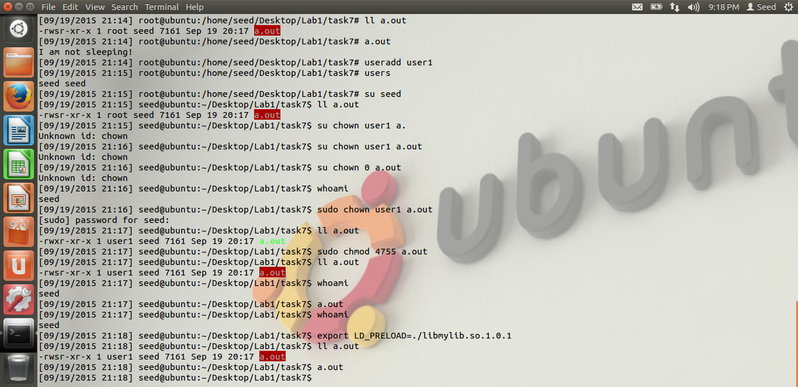

**Observations:** There are lot of observations from the above screen shot. First, we create a new user called user1, using the useradd user1 command. Then, we make our program owned by that user i.e. user1. Also, we make it a set-UID program. Thus from the screen shot, we can see that the owner of a.out is user1 and it’s a set-UID program. Then we login as seed user, we again export the library as we have changed the user, and then run the a.out, the priviledged program. The output is, the program sleeps for some time. It does not display “I am not sleeping” message. The reason is the same. As it’s a set-UID program, the LD_PRELOAD is being cleaned before running. Hence the system sleep() command is run, instead of our library. Hence, we don’t see the display message.

Thus, we have observed various scenarios.

# TASK 8: INVOKING EXTERNAL PROGRAMS USING system() and execve()

The screen shot for task-8 are below.

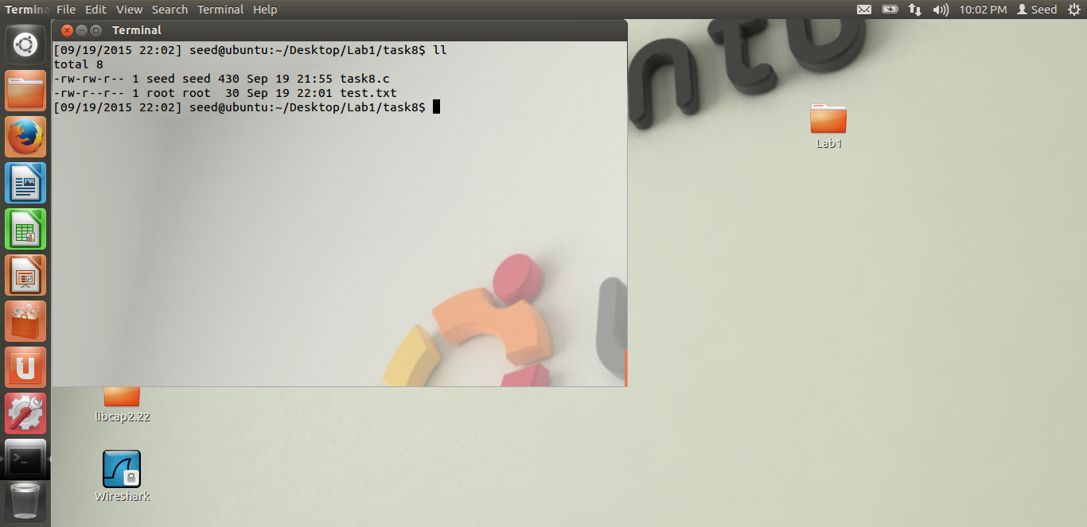

**Observation:** In the above screen shot, we just see that, I have created a file called test.txt. This file has root as its owner. The files was created by logging to root account. As we see from the privileges, others have just the read privileges. They don’t have modify privileges.

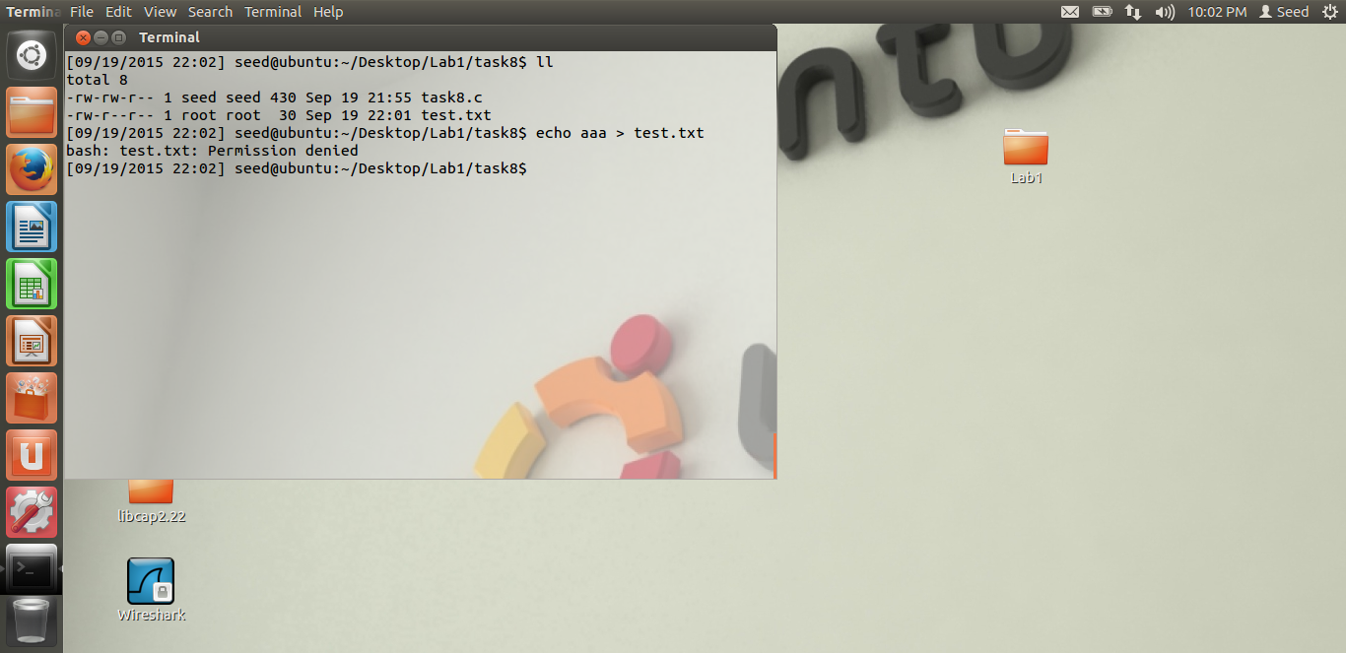

**Observation:** We can see that, when we are logged in as seed, and when we try to write/modify the test.txt file, we don’t have the permission rightfully, as this file is owned by the root and we could just read the file.

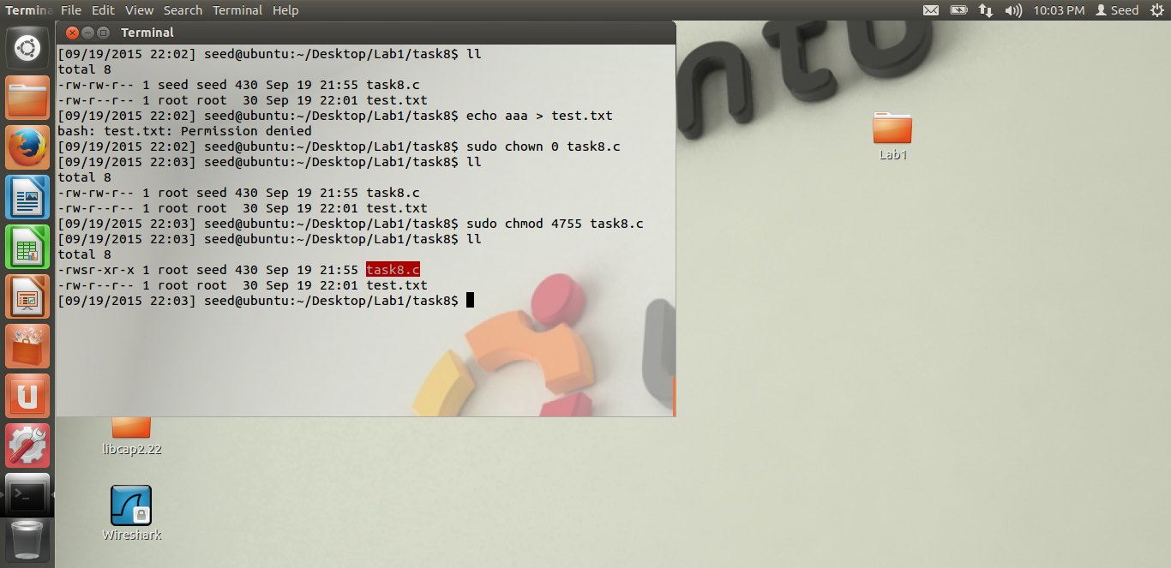

**Observation:** From the above screen shot we can see that, we have made the program as a set-UID program and made the root as its owner.

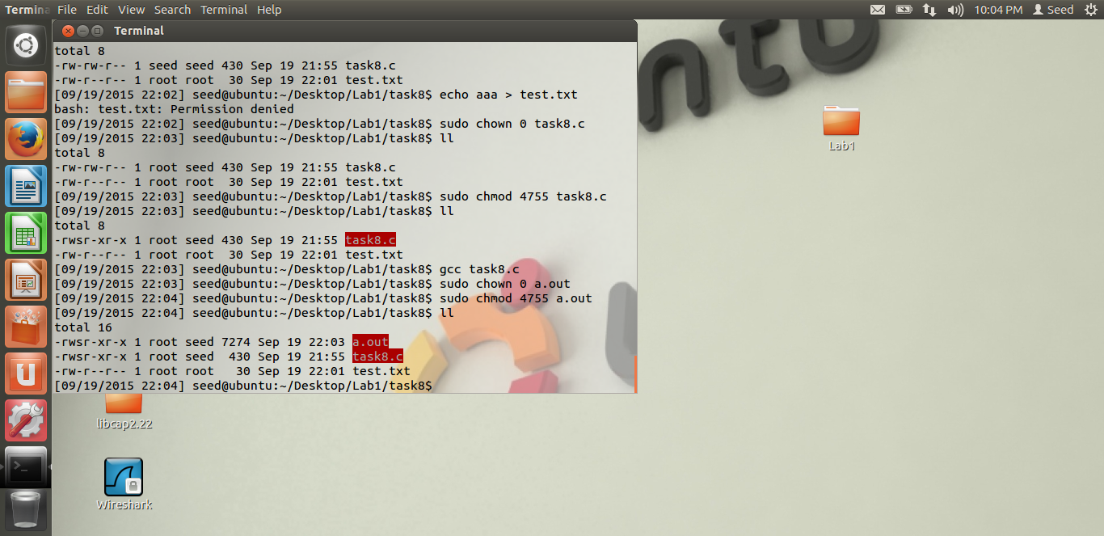

**Observation:** We could see that, we have made the executable file, a.out as the set-UID program and made its owner as the root.

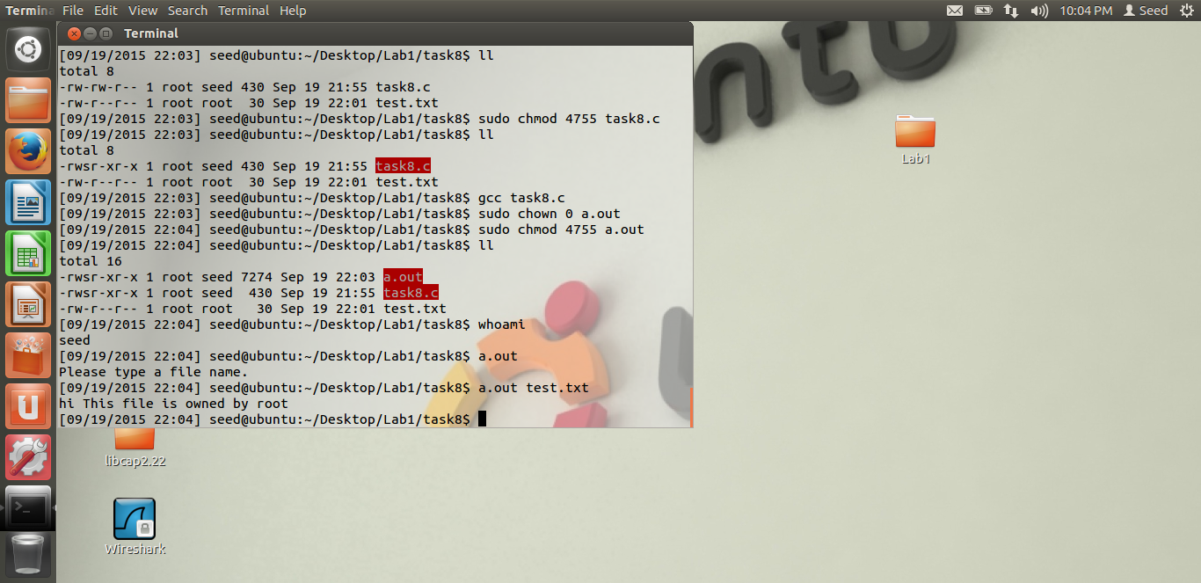

**Observation:** When we run the executable file, a.out, without any argument, It displays to type a file name. And we can see that when we give it a file name, test.txt which is owned by the root, we could see its contents displayed.”hi This file is owned by the root.” This is a normal set-UID program which we are running.

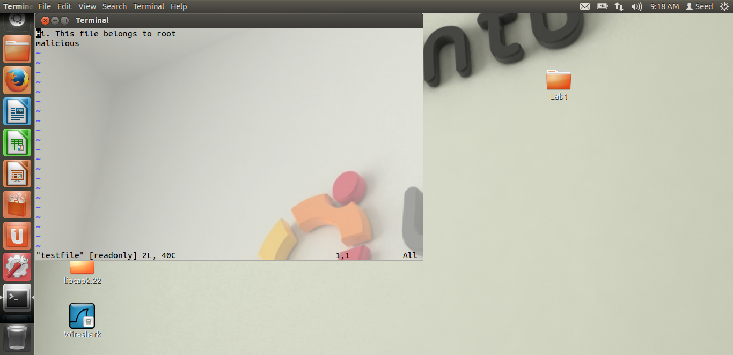

**Observation:** We could see the contents of the file. We could also see that, it’s a read only file from the screen shot. The Malicious word was added by the root. To a testfile, which we will attack.

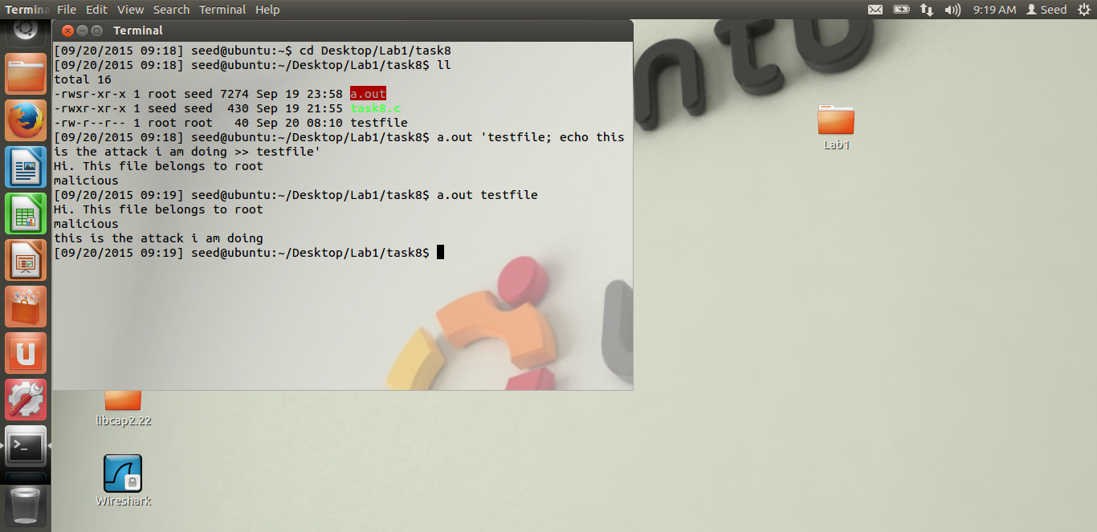

**Observation:** This is the attack which we can do through the user input. The file test.txt was not writable to us,seed. But when we run the set-UID program and gave another command along with the filename like a.out ‘testfile;echo something >> testfile’. So, firstly, we can see that the testfile, is owned by root. Other users have only read permission. But when we run the set-UID program, and when we give one more command, as the system uses shell to execute the command, the shell is very powerful. It can execute 2 commands, separated by semicolon. So, even though the file is only read-only, as the user’s privileges have been upgraded, the user can use this to attack the system. As we can see, we have added, “This is the attack I am doing” in the read-only file. Thus, when we display the content after the attack, we can see the added content. Thus, the integrity of the system has been compromised.

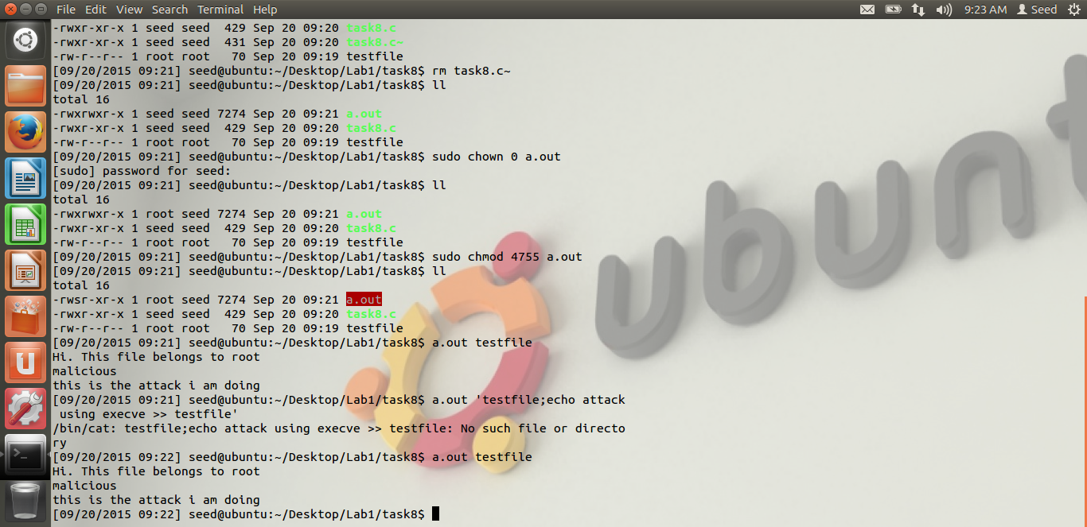

**Observation:** On the other hand, when we use execve() instead of system, we get the error as displayed in the screen shot, i.e. No such file or directory. As the execve() directly does a system call, our attacks in step-1 does not work. Execve() uses system call directly, and not invoke the shell, hence it is safe. Hence, we were not able to successfully attack the system using execve().

# TASK 9: CAPABILITY LEAKING

The screen shot for task-9 is below.

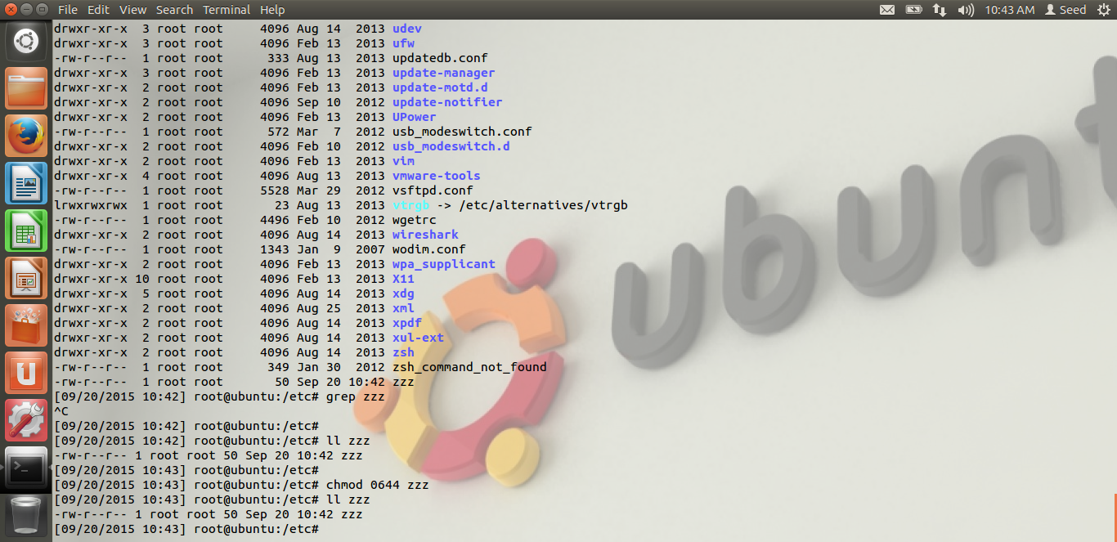

**Observation:** We observer that, for the attack, we create a file in the /etc/zzz. We do this by first logging in as root, then creating the file, and giving the permission as 0644, i.e. the file is just readable to other users.

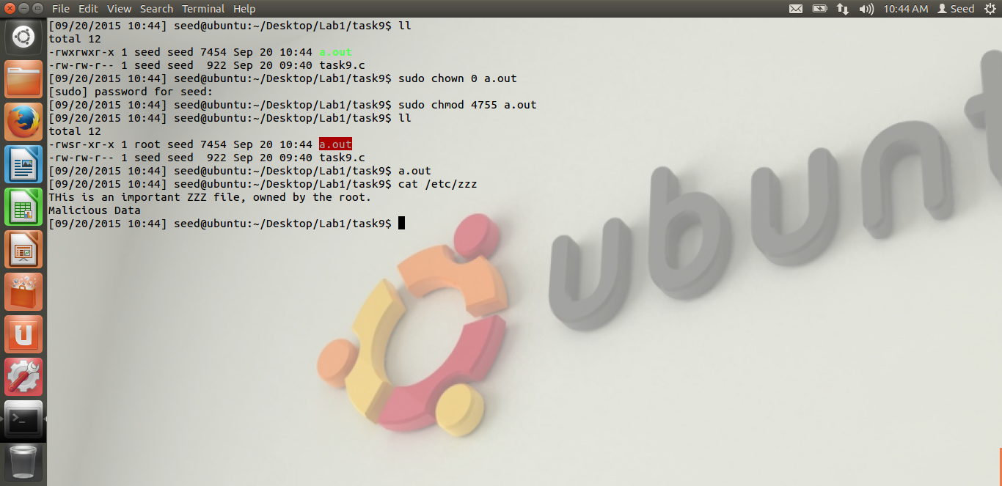

**Observation:** As we see from the screen shot, firstly, we compile the program and make its owner as root, and make it a set-UID program, as seen from the screen shot. Then, we run the program. Please note that seed user is running the program. In the program which Dr. Du has given, there is a capability leak. What this means is, when the seed user is running the program, its privileges are upgraded to root to do a particular task. In our example, the fd, file descriptor of the /etc/zzz file, which is a protected file of the root is the key. The seed user has this fd descriptor in the program. But when the work is over, the root privileges are no longer required. Thus, we use the setid(getuid()), it returns the real uid, i.e. it returns seed. But if we forget to close the fd, even though the root privileges are invoked, the user still has the fd control, as it was not close. Thus, the user has added the malicious Data line, as we can see in the screen shot above. Thus, seed has modified the read-only file, because of capability leak, fd not being closed. This is the attack done successfully.